osTicket

osTicket is the ticket request system used for customers to request for services from the help desk. On the osTicket website, a technician can manage inquiries, messages, incoming tickets, the FAQ, and much more.

# Accessing the osTicket site

To access the osTicket site as a customer, open a web browser and type: [**http://pcsupport.ecc.iwcc.edu/**](http://pcsupport.ecc.iwcc.edu/)

The webpage should look like this.

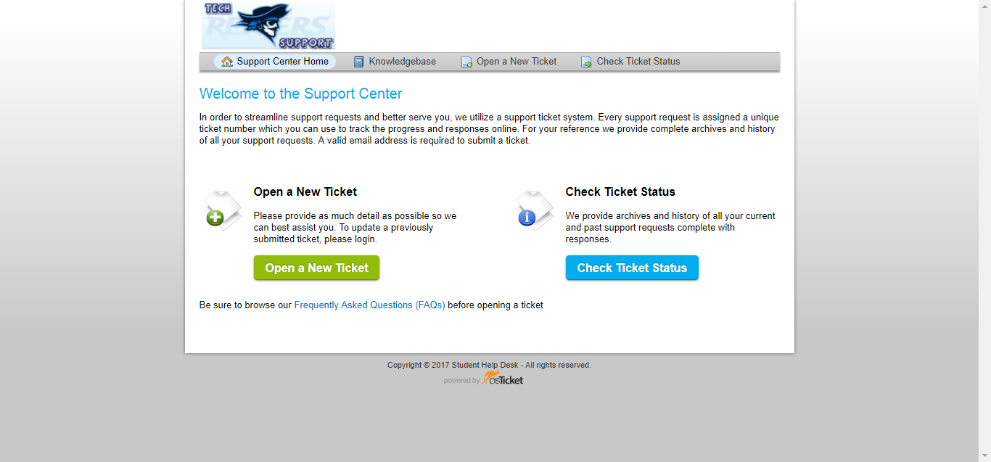

This is useful information to give to any non-technician customer that may need to create a ticket in the future without the help of a technician. However, in this manual we won’t be focusing on this page too much.

To access the osTicket site as a technician, open a web browser and type:

[**http://pcsupport.ecc.iwcc.edu/scp/**](http://pcsupport.ecc.iwcc.edu/scp/)

The webpage should look like this.

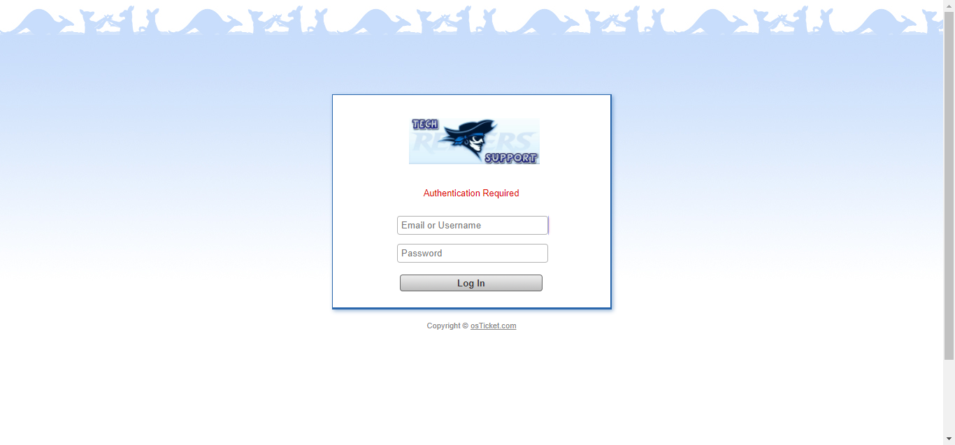

Simply type in your username and password to proceed to the technician page.

(If you have forgotten your password, or do not recall making an account for osTicket, please contact a supervisor)

Once you have logged in, the webpage should look similar to this.

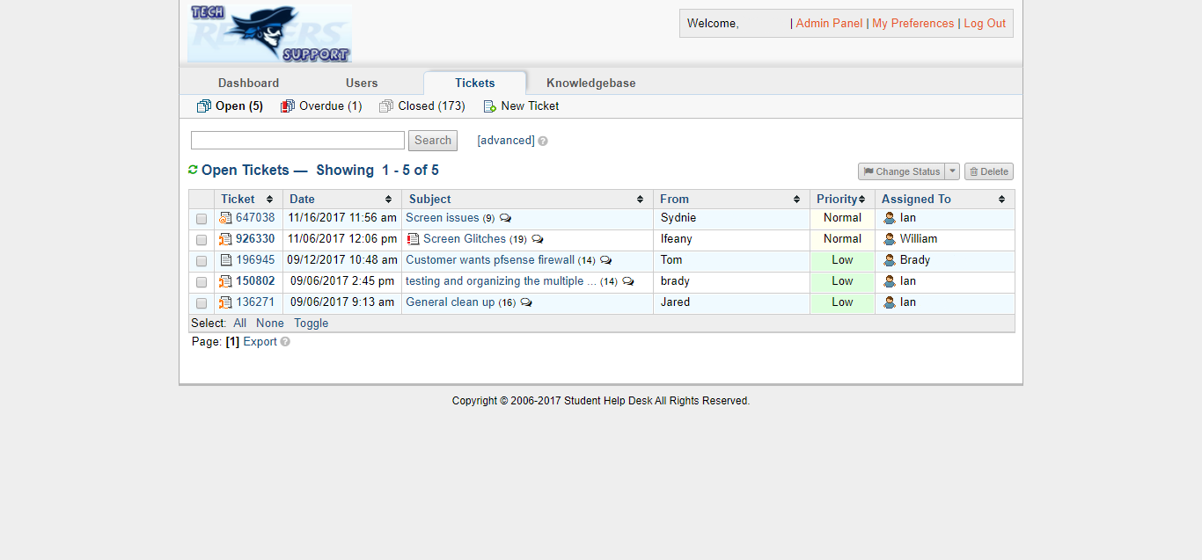

# Opening a new ticket

To create a new ticket:

1. After logging into the osTicket site, click on “**New Ticket”** at the top of the tickets list page.

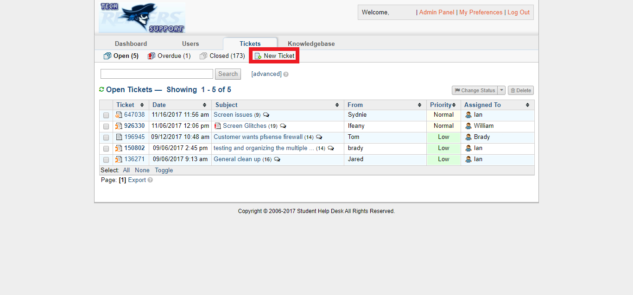

2. On the “**Open a New Ticket”** page, you must fill in the customer and ticket information:

* E-mail address of the customer - *Ask customer.*
* Customer’s full name - *Ask customer.*
* Help topic - *What is the topic of the issue?*
* Department - *Which department does the issue belong to?*
* SLA Plan - *Which SLA will this incident fall under?*
* Due Date - *What is the time frame this incident will have to be solved in?*
* Assign To - *Who will handle the ticket? Will it be the creator or will it be handed off to a different agent?*

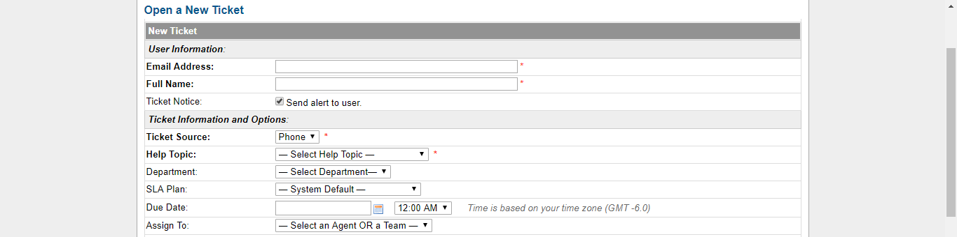

3. Below the information boxes, you will describe the issue. Here is where you will title the issue by using a short issue summary and describe the issue in full detail within this box.

After defining the issue, you will define a priority level. How urgent is the issue? Is it something that needs to be solved immediately or could do with taking a few days to solve?

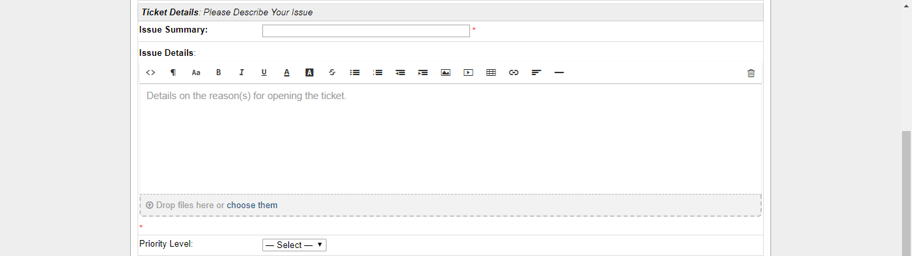

4. Once the issue has been defined, it is time to choose a response for the ticket.

A ticket response is entirely optional and skipped over. For ticket response, there are a few options one could choose. A canned response would be the easiest option. A canned response is a list of a responses already pre-made. From the drop down list, you would select the most appropriate response. However, if you decide to, you could make up your own response in the text box.

After deciding on a ticket response, you will choose whether to keep the ticket open or close the ticket. Keep in mind, the ticket should only be closed if the issue has been solved and customer has picked up an necessary devices.

If your department has and uses a set signature, you can choose whether or not to display it in the ticket response. If you are unsure, you can ask another technician or contact a supervisor.

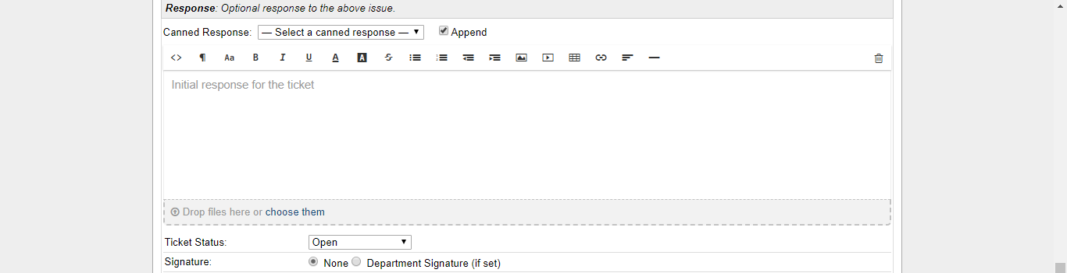

5. Internal notes will be notes only seen by other technicians. If you have any input or advice about the issue, here is where you would communicate it to the technician assigned to the ticket.

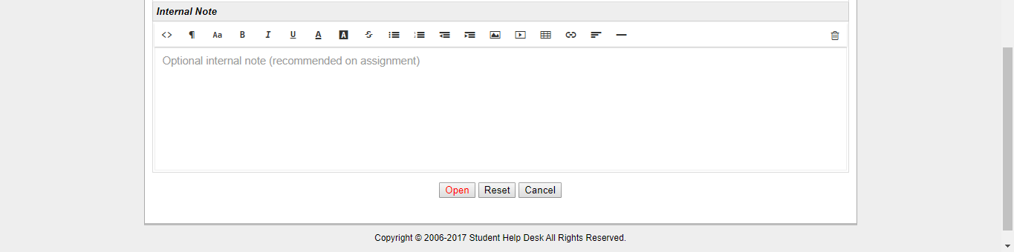

6. Once you have all the information in order, click “**Open**.” Your new ticket should appear in the open tickets section of osTicket.

## Ticket Creation Information Process Map

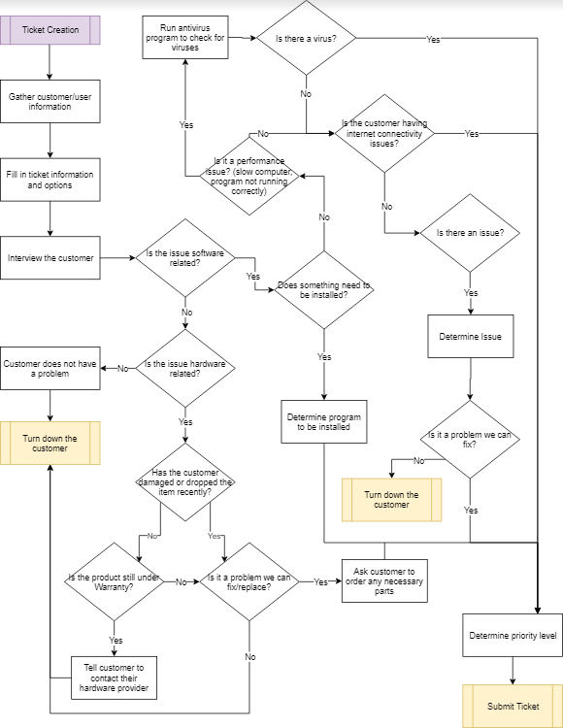

# 

# Ticket Management

As a technician, you may have to do some ticket management, which would include reassigning tickets, viewing and adding internal notes, changing the due date or ticket status, etc.

## Tickets Front Page

On the front page, you will be able to see general information about open, closed, and overdue tickets.

Beginning on the left hand side, you will see the ticket numbers. This is used as a reference for the specific ticket you or the customer may be looking for. Each number is unique to the case it represents so there are no two alike numbers.

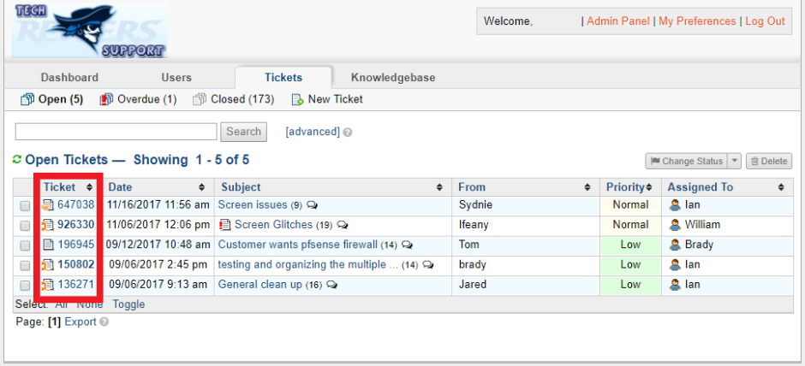

Next, you will see the date the ticket was created, the subject of the ticket and by whom it was created.

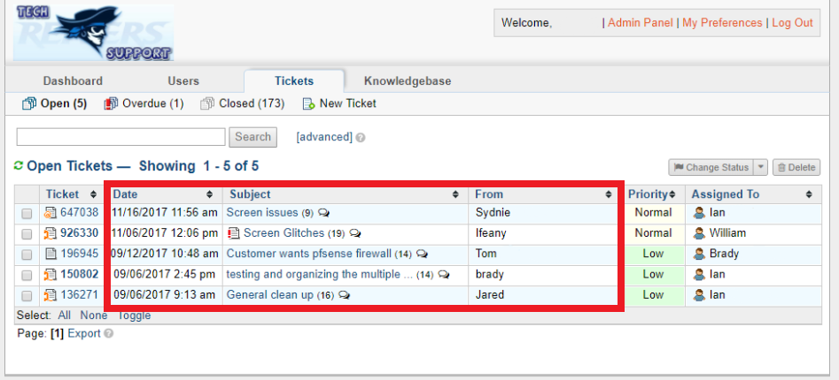

Lastly, you will see the priority level of each ticket and the technician it has been assigned to.

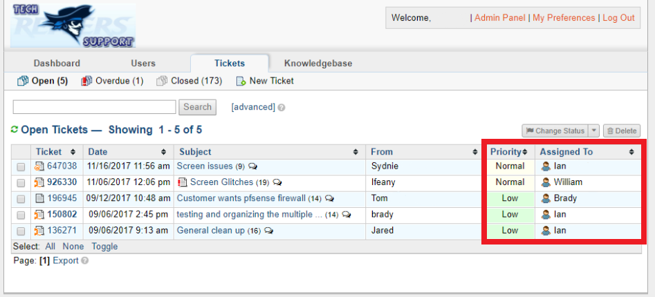

## 

## 

## Ticket Thread

When you click on a ticket number, it will open up the ticket thread. Here, you will see general ticket info, ticket status, priority, ticket creation, due date, technician assigned, customer name and contact info.

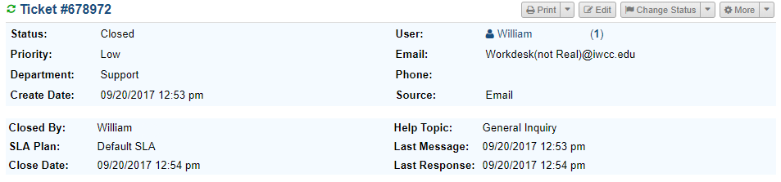

Below the ticket information box is the ticket thread. The ticket thread will display all the internal messages between technicians and automated messages by the system, such as ticket overdue messages. These messages are color coded as such:

**Blue** - Initial message describing the issue

**Yellow** - Internal messages by the technicians and system

**Orange** - Reply messages sent to the customer with the ticket

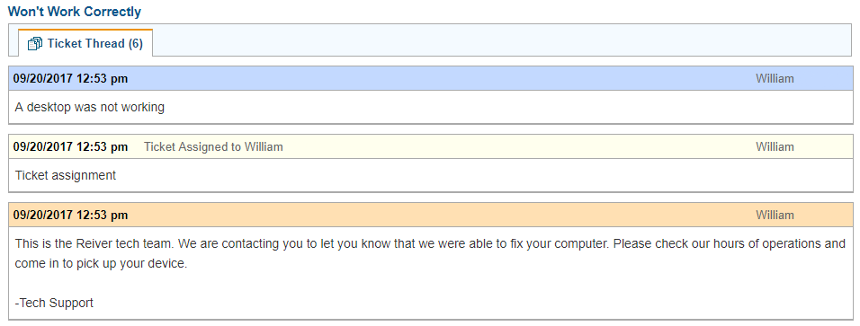

## Responding, Resolving, Closing

Under the ticket thread, you are able to post your own replies to the customer by selecting “**Post Reply**.” You can select from the list of canned messages or make up your own. This will send an e-mail directly to the customer and can be used when you are in need of more information from the customer or giving updates on the status of the issue.

If you select “**Post Internal Note**” you can post replies that only technicians will be able to see. This is useful in asking for or giving advice in order to resolve an issue quicker.

From both these tabs, you can also change the status of the ticket from **Open** to **Waiting Response, Resolved** or **Closed.**

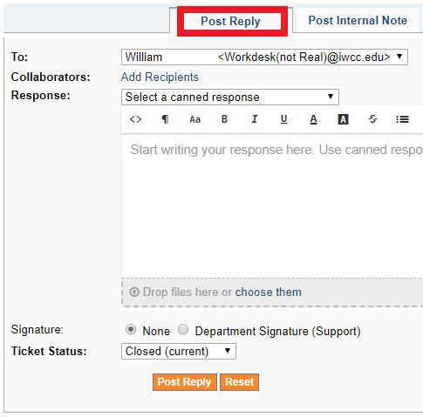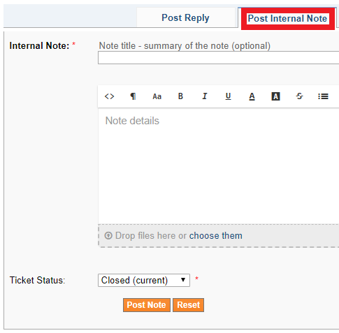

# Using the FAQ

Our osTicket site provides a technician operated knowledge base, or more commonly referred to as an FAQ (Frequently Asked Questions). This is useful for any common issues or questions that arise, they can be put in the the FAQ for others to use.

This is not only visible to technicians but can also be made visible to customers. Rather than customers bringing in their device for any small issue, they can first browse the FAQ knowledgebase for an answer to their problem.

To access the FAQ, click on the “**Knowledgebase**” tab at the top of the page. It’ll bring you to the FAQ forum.

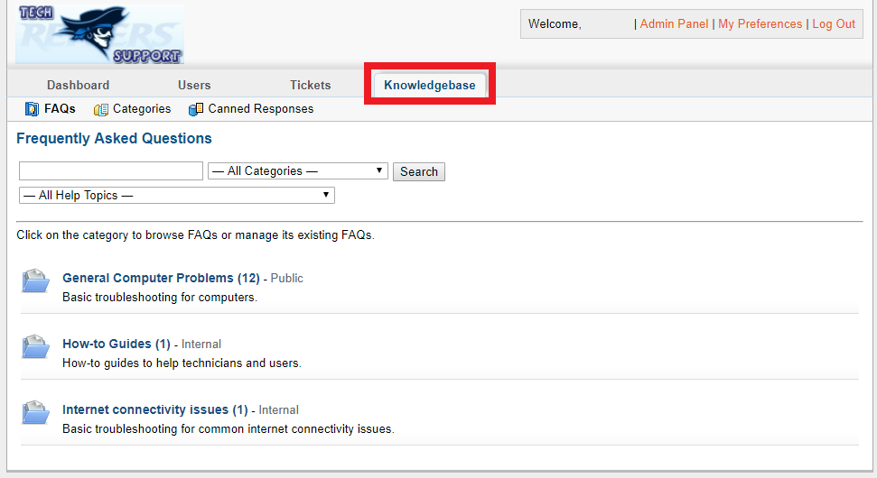

From this page you can browse the categories for more information on how to solve an issue, granted it is kept updated frequently.

As more common issues and questions arrive, it may be useful to you and your fellow technicians to add your own expertise to the FAQ.

To add on to the FAQ:

1. Select the category in which your topic belongs to. If there is not a category created for your topic, select the closest one or create a new one by selecting “**Categories”**

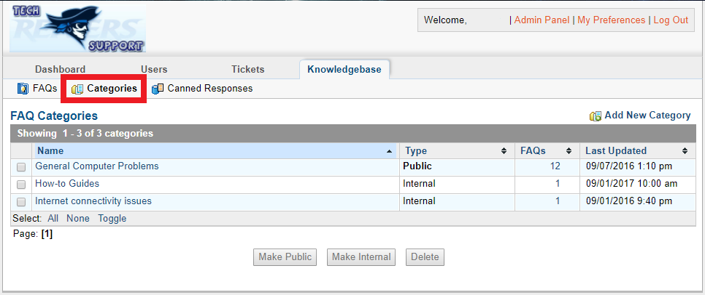

From this page, select “**Add New Category”** provide the new Category Name, Description, Internal Notes, and Category Type (Public or Private). Once you have provided the necessary info, click “**Add”**.

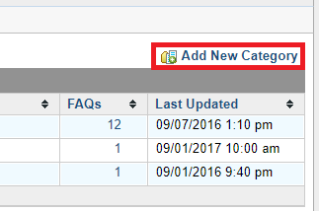

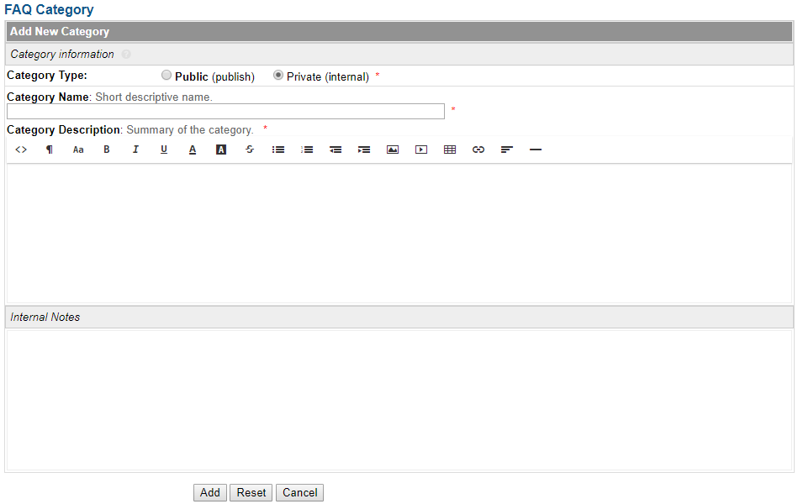

2. Once you have chosen or created your category, on the “**FAQ”** page, select the category you decided or created. On the next page, you will select “**Add New FAQ”** to add on to the list of Frequently Asked Questions.

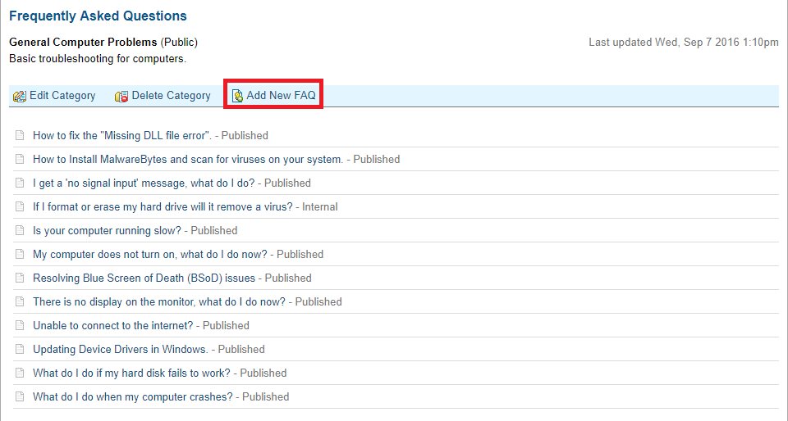

3. From here, you must specify the question that is being answered. The category listing should be left the same as it is the category you originally selected, however if you made a mistake, it can also be changed from this page.

You can also choose whether the FAQ will be visible to customers (public) or only to technicians (internal). Is it information that a customer could find valuable? Or is it something more specific to technicians?

# 

4. Attachments such as visual images would also give the customer that is not necessarily tech savvy more of an advantage on solving their issue. Technicians may also find images convenient such as when taking apart and putting back together any sort of device. However, attachments are entirely optional.

# 

5. Lastly, you will select any help topics related to your FAQ. This is also completely optional but may help when the customer or technician is searching for something specific to that topic.

Internal notes can also be left to any future technician from here as well. Once all your FAQ information is in order, click "**Add FAQ”**

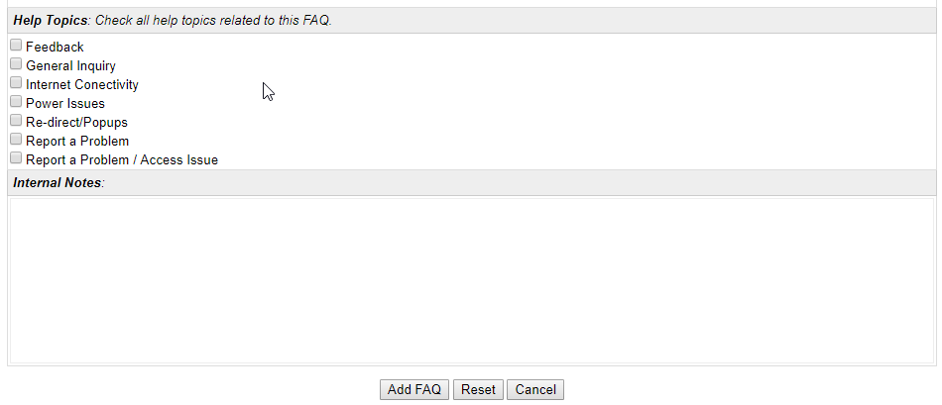

# 

# 

# Setting up new users

Sometimes a customer may have more issues in the future and decide to come back. By creating a user account for them, it’ll speed up the process of submitting a ticket. The **“Users”** tab houses all the of users guest and registered accounts in the system.

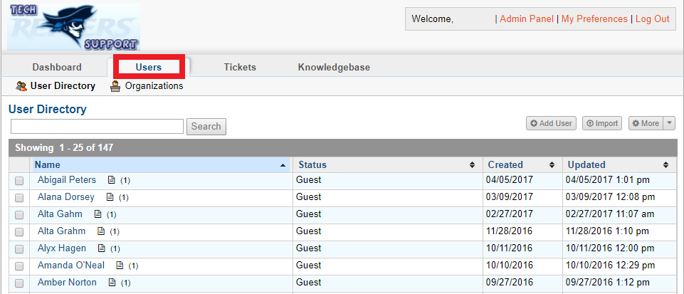

As you’ll notice, plenty of these accounts are “**Guest”** accounts as an account is made for each person that makes a ticket. It is not required to have a registered account but is recommended for frequent customers.

To register an account already in the system, click on the user you would like to register, and click “**Register”** in the top right.

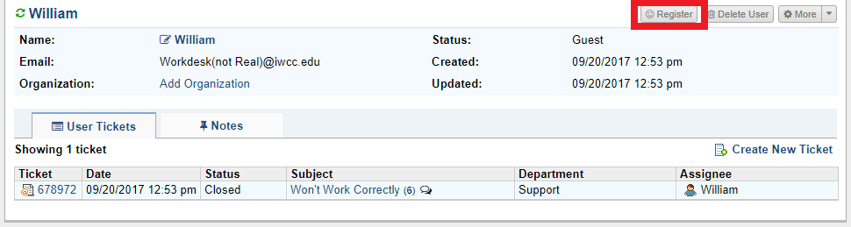

This will bring up a window to which you can create the user’s username and create their new account.

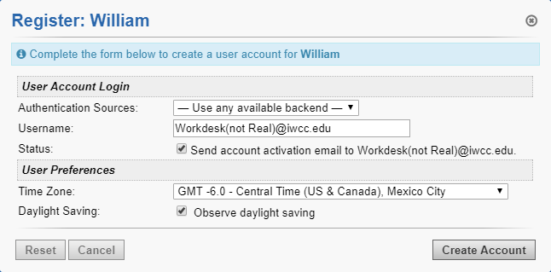

If by chance the user is not in the system, you can set up a new user by scratch by clicking on “**Add User**” from the User Directory.

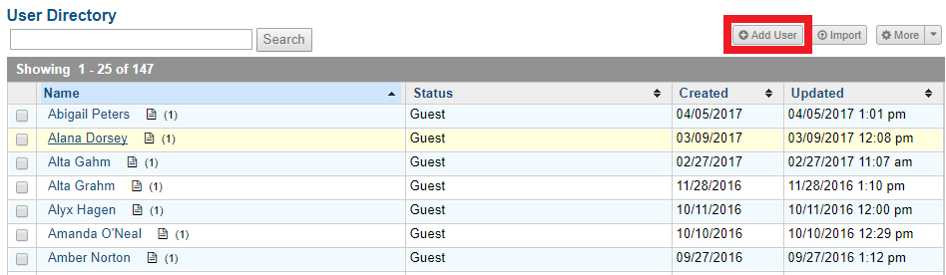

This will bring up a window in which you will provide the user’s Email Address, Full Name, Phone Number, and any internal notes on the user.

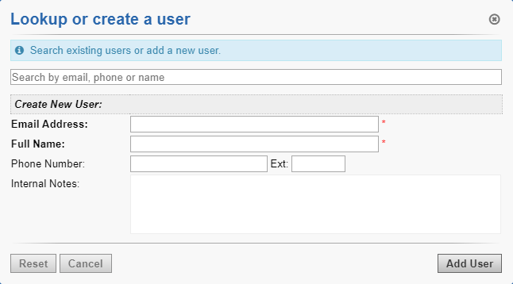

Ticket Assignment Policy

As tickets are made, the must be assigned to a technician in order to be resolved and closed. But what technicians will take what tickets? This may also be a matter of which technician is trained in what areas, otherwise known as specialists. One technician may know more about hardware problems then others, hence, they would recieve a hardware issue ticket.

As we do not have an automatic ticket assignment process available, the ticket should be submitted without assignment and allow all agents to provide input and decide ticket assignment. It will also allow the technician with better knowledge about a certain topic to claim the ticket rather than have it automatically assigned to another technician that may not know as much.

This method requires all analysts to be alert to when a ticket comes in as to not dissatisfy the customer. Tickets should be monitored by a supervisor to assure they are being claimed by technicians in a timely manner.